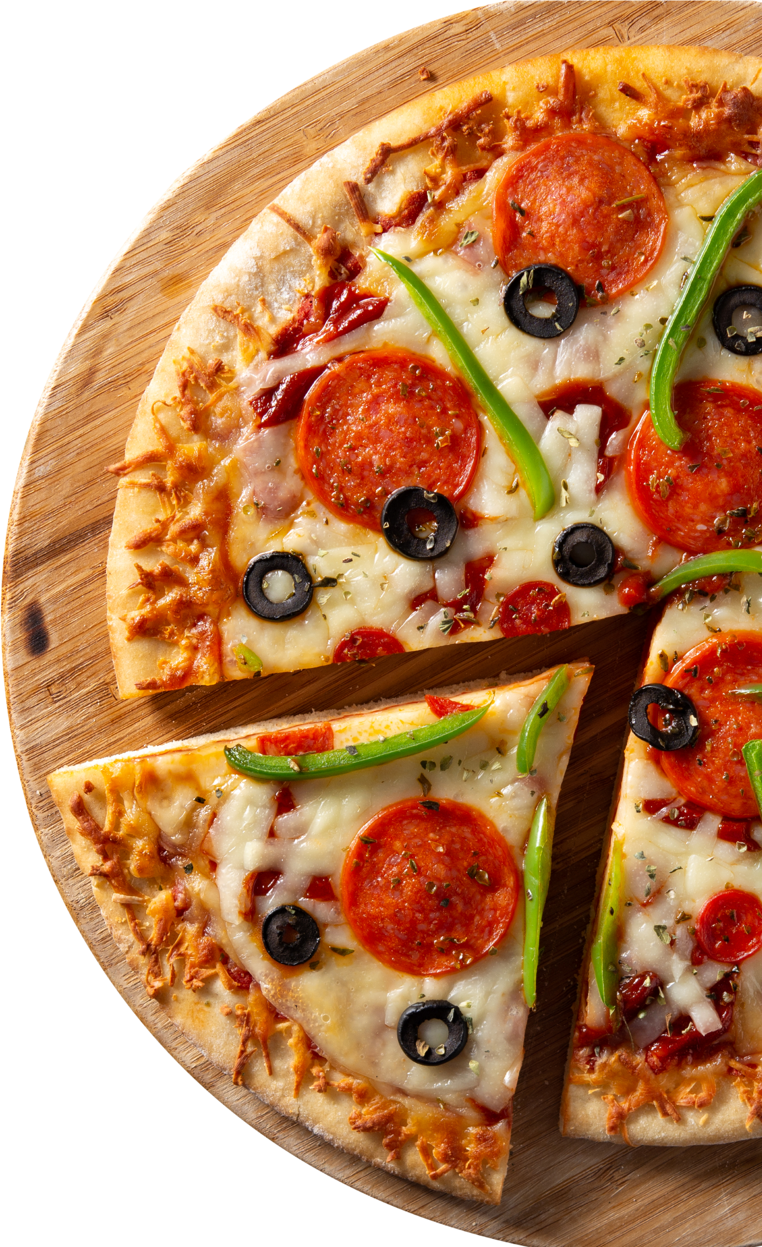

PIZZA

E

S

SAL

**INTRODUCTION**

Hello everyone my name is Prashant

Tiwari. In this project, I have utilized

SQL queries to analyze and solve various questions related to pizza sales.

Through the analysis, I aim to uncover

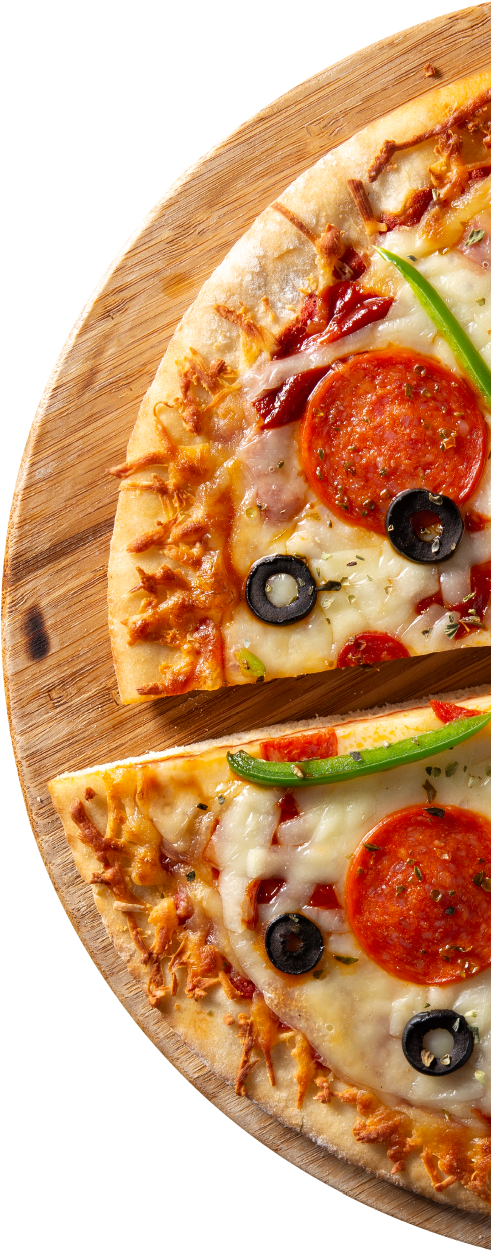

key insights and trends within the data,

which can help inform decision-making processes and optimize sales

strategies. By leveraging extract,

manipulate, and interpret the data,

providing a comprehensive overview of the pizza sales dynamics

# OVERVIEW OF PROJECT

In this project, I utilize SQL queries to perform a comprehensive analysis of data. the analysis is structured into three levels of complexity: **Basic analysis:-**

Retrieve the total number of orders placed.

Calculate the total revenue generated from pizza sales.

Identify the highest-priced pizza.

Identify the most common pizza size ordered.

## Intermediate Analysis:-

Determine the distribution of orders by hour of the day.

Join relevant tables to find the category-wise distribution of pizzas. Group the orders by date and calculate the average number of pizzas ordered per day.

Determine the top 3 most ordered pizza types based on revenue.

## Advanced Analysis:-

Calculate the percentage contribution of each pizza type to total revenue.

Analyze the cumulative revenue generated over time. Determine the top 3 most ordered pizza types based on revenue for each pizza category.

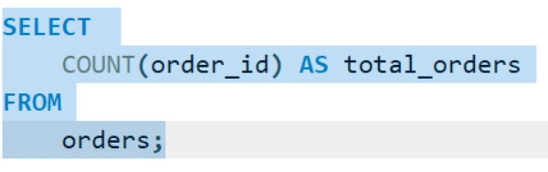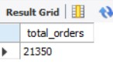

SALES

**Retrieve the total number of orders**

**placed.**

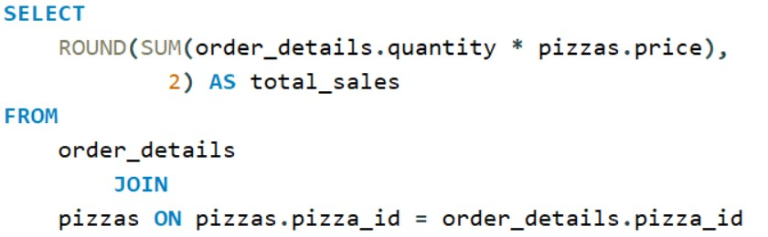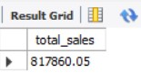

SALES

**Calculate the total revenue**

**generated from pizza sales.**

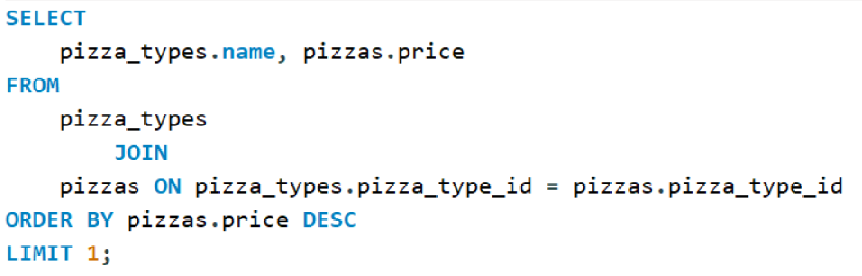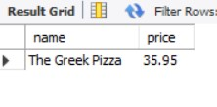

SALES

**Identify the highest-priced pizza.**

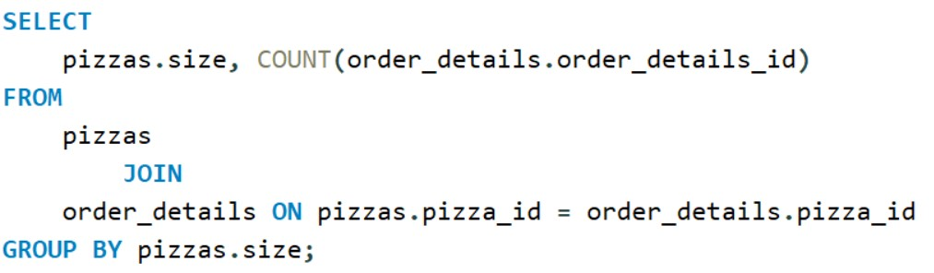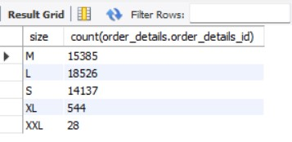

SALES

**Identify the most common pizza size**

**ordered.**

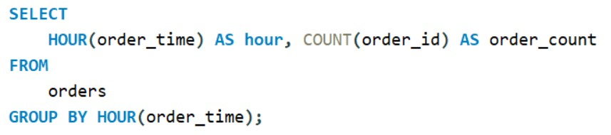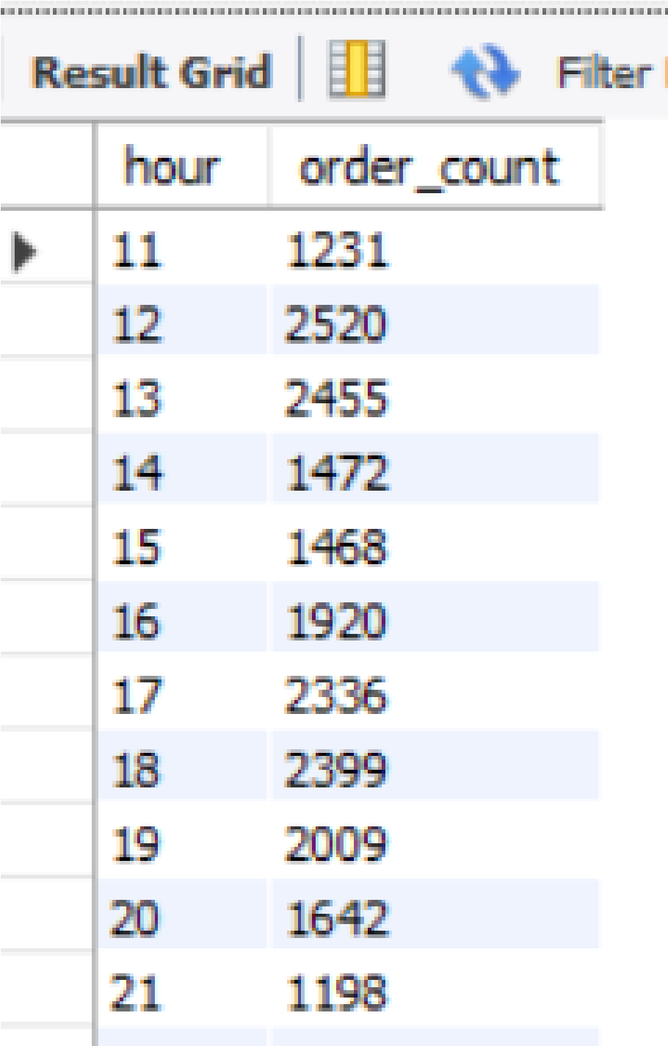

SALES

**Determine the distribution of orders**

**by hour of the day.**

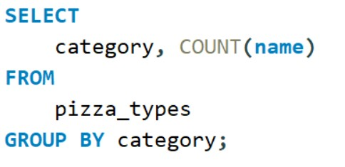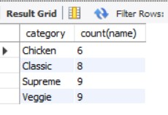

SALES

**Join relevant tables to find the**

**category-wise distribution of pizzas.**

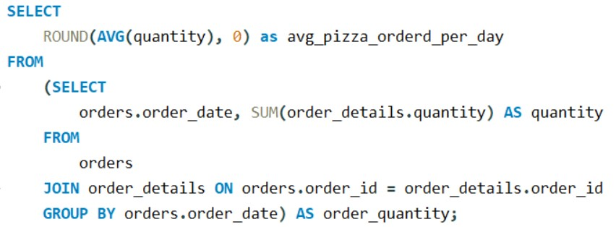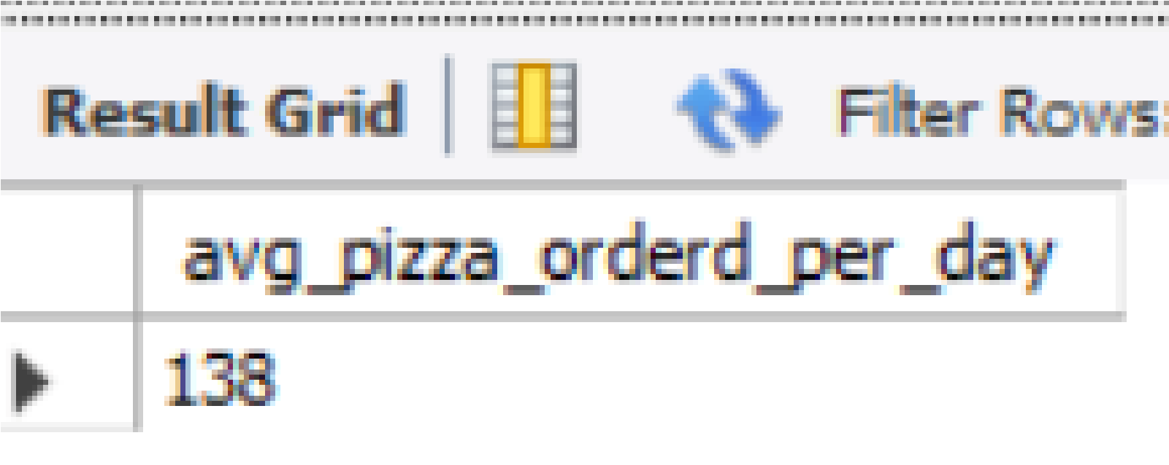

SALES

**Group the orders by date and calculate**

**the average number of pizzas ordered**

**per day.**

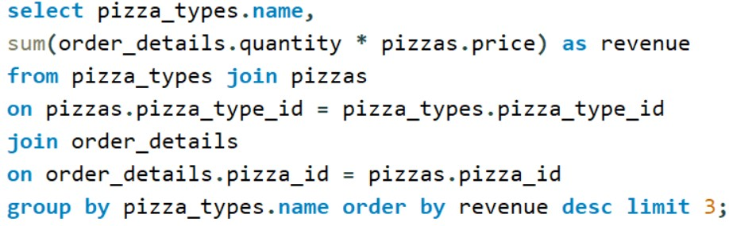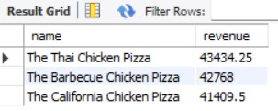

SALES

**Determine the top 3 most ordered**

**pizza types based on revenue.**

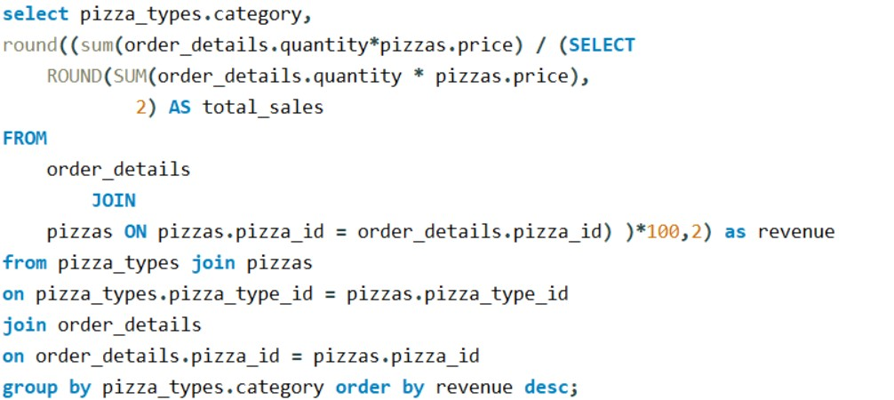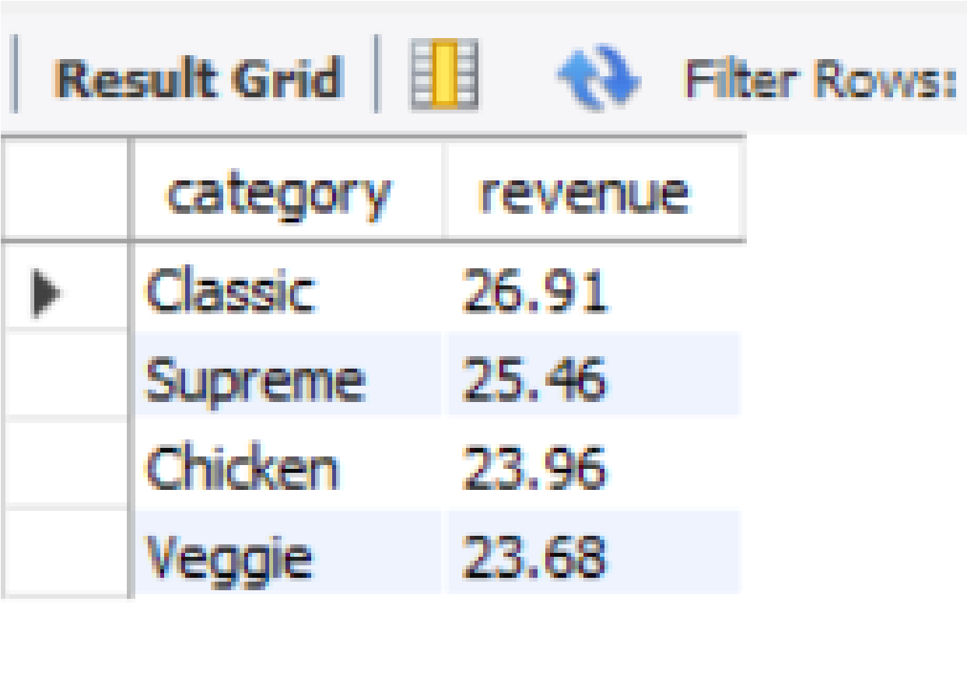

SALES

**Calculate the percentage contribution**

**of each pizza type to total revenue.**

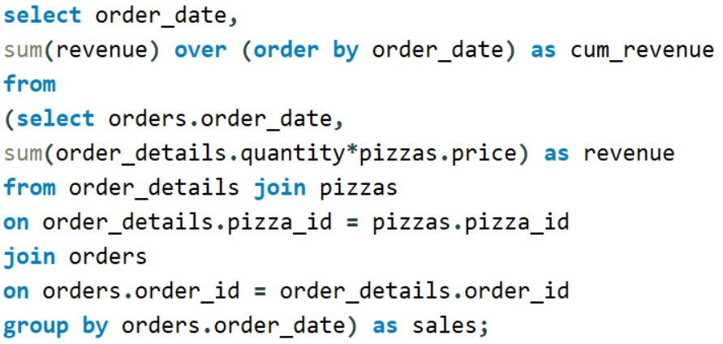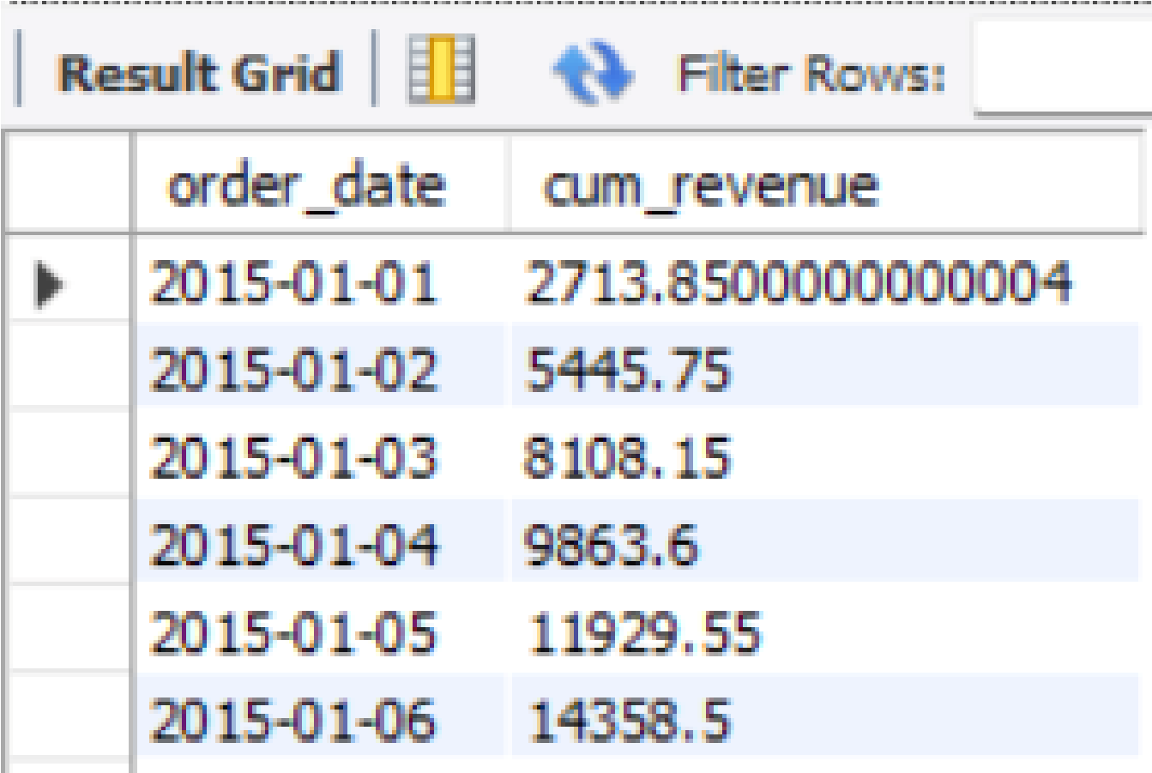

SALES

**Analyze the cumulative revenue**

**generated over time.**

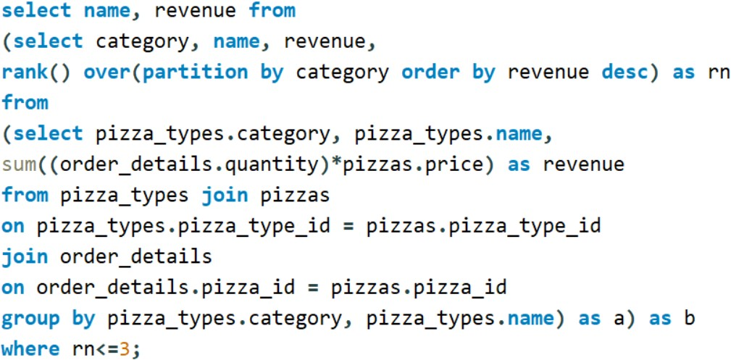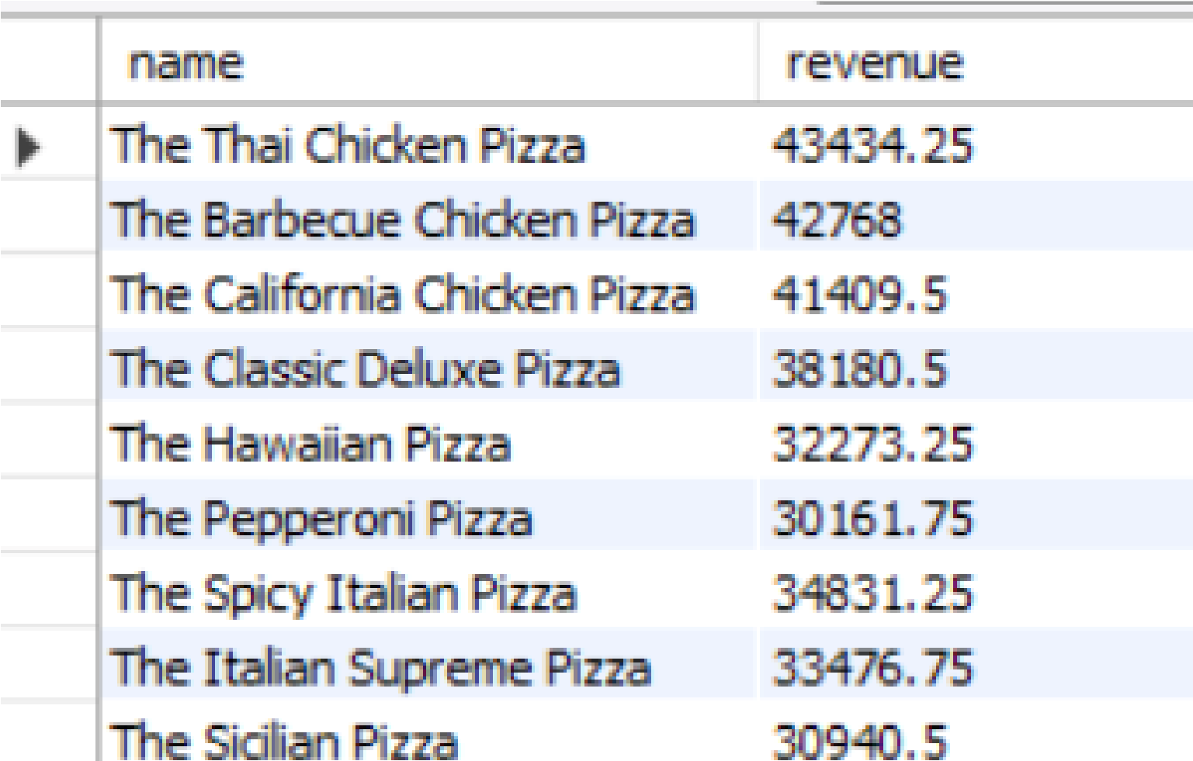

SALES

**Determine the top 3 most ordered pizza**

**types based on revenue for each pizza**

**category.**